QA - Automation and Development

Part 1

**Name:** Rotem Bussani.

**ID:** 312118946

**Email:** [RotemBussani@Gmail.com](mailto:RotemBussani@Gmail.com)

**Name of course:** QA- Automation and development.

Table of Contents

**1. Introduction: 3**

**2. Objectives and Tasks: 3**

**2.1 objectives: 3**

**2.2 Tasks: 4**

**3. Scope: 5**

**4. Test Plan: 6**

**5. Test Cases and Bug Reports: 7**

**5.1 STD: 7**

**5.2 Bug Reporting and Tracking: 8**

**5.3 Jira: 9**

# Introduction:

Facebook (Figure ‎1‑1) is a social media platform that was founded in 2004 by Mark Zuckerberg. The website's primary purpose is to connect people and allow them to share information and communicate with each other online. The Facebook website and mobile app offer a range of functions, including:

* User registration and login.
* Profile management.
* News feed and timeline display.
* Messaging and chat.
* Media sharing (photos, videos, etc.).

Figure ‎1‑1: Facebook Logo

* Groups and events creation and management.

The purpose of this testing is to identify any issues or defects in the functionality of Facebook's website and mobile app, ensuring that they are reliable, user-friendly, and meet the needs of the intended audience.The testing project will cover various areas, including but not limited to, user registration, login and authentication, profile management, media sharing, posts, search, and other functions of the Facebook website and mobile app.The intended audience of this STP includes the development team, quality assurance team, project managers, and other stakeholders involved in the development and testing of Facebook's website and mobile app. The manual testing will be conducted using various types of tests, such as: functional testing, usability testing, performance testing, compatibility testing and security testing, to ensure that the Facebook website and mobile app perform optimally and provide a seamless user experience.

# Objectives and Tasks:

## objectives:

1. Validate functionality: The primary objective of manual testing is to validate the functionality of the website and mobile app. This involves performing tests on the features and functionalities of the website and mobile app to ensure that they work as intended and meet the requirements.
2. Identify defects: Another objective of manual testing is to identify defects on the website and mobile app. This involves executing tests to identify defects or issues on the website and mobile app, such as broken links, UI errors, performance issues, and security vulnerabilities.
3. Improve user experience: Manual testing aims to improve the overall user experience of the website and mobile app. This involves ensuring that the website and mobile app are easy to use, navigate, and understand, and that they provide a seamless and engaging user experience.
4. Ensure compatibility: Manual testing also ensures compatibility of the website and mobile app across different platforms, devices, and browsers. This involves testing the website and mobile app on different devices and platforms to ensure that they work as intended and provide a consistent user experience.
5. Meet regulatory compliance: Manual testing aims to ensure that the website and mobile app meet regulatory compliance requirements. This involves testing the website and mobile app to ensure that they adhere to industry standards and regulations, such as accessibility guidelines, data privacy laws, and security standards.  
     
   The objectives of manual testing for Facebook's website and mobile app are to validate functionality, identify defects, improve user experience, ensure compatibility, and meet regulatory compliance.

## Tasks:

1. Validate functionality:

* Create test cases based on functional requirements.
* Execute manual tests on the website and mobile app to validate functionality.
* Record system and collaborate with developers to resolve them.
* Re-test defects to verify fixes.

1. Improve user experience:

* Perform usability testing to identify areas for improvement in user experience.
* Provide feedback to the development team on areas for improvement.
* Monitor user feedback and analytics to identify areas for further improvement.

1. Ensure compatibility:

* Test the website and mobile app on different browsers, operating systems, and devices.
* Identify any compatibility issues and work with the development team to resolve them.

1. Meet regulatory compliance:

* Ensure the website and mobile app comply with relevant accessibility guidelines, data privacy laws, and security standards.
* Perform testing to validate compliance with relevant regulations and standards.
* Work with the development team to address any compliance issues found.

# Scope:

The Software Test Plan (STP) for the Facebook website and mobile app covers a comprehensive set of tests to ensure high standards of quality, performance, usability, compatibility, and security for the platform. These tests include functional testing to ensure all functions meet requirements, usability testing for ease of use, performance testing to ensure platform performance under expected user loads, compatibility testing for different devices and browsers, and security testing for data protection against unauthorized access or breaches. The STP serves as a guide for effective and efficient testing and reporting of issues or defects found during the testing process. Overall, the STP for the Facebook platform aims to ensure a positive user experience while maintaining high standards of quality and security.

Functional Testing: Defining test cases for all functions and executing them. Test cases can be designed based on functional requirements and user scenarios.Usability Testing: Test the overall user experience. Test results can be analyzed to identify areas for improvement.Performance Testing: Simulating expected user loads and monitoring platform performance. Tools such as load testing software can be used to measure and analyze performance.Compatibility Testing: Testing on different devices and browsers, such as desktops, laptops, smartphones, and tablets. Security Testing: Vulnerability assessments, penetration testing, and code reviews to identify potential security risks.

# Test Plan:

1. Functional Testing:

* Identify functions of the Facebook website and mobile app.
* Create test cases based on functional requirements and user scenarios.
* Execute test cases to ensure all functions meet requirements.

1. Usability Testing:

* Conduct user tests on ease of use, user interface, and overall user experience.
* Analyze results to identify areas for improvement.

1. Performance Testing:

* Define expected user loads for the Facebook website and mobile app.
* Simulate user loads and monitor platform performance using load testing software or network monitoring tools.
* Analyze results to identify performance bottlenecks and areas for improvement.

1. Compatibility Testing:

* Test Facebook website and mobile app on different devices and browsers, such as desktops, laptops, smartphones, and tablets.
* Ensure compatibility with different operating systems, such as iOS and Android.

1. Security Testing:

* Conduct vulnerability assessments, penetration testing, and code reviews to identify potential security risks.
* Test data protection against unauthorized access or breaches.

**All Test Cases were Documented on the “Jira” platform.**

# Test Cases and Bug Reports:

## STD:

Figure ‎5‑1 and Figure ‎5‑2 show the test cases performed on the Facebook website and mobile application.

Figure ‎5‑1: Test Cases (1-20)

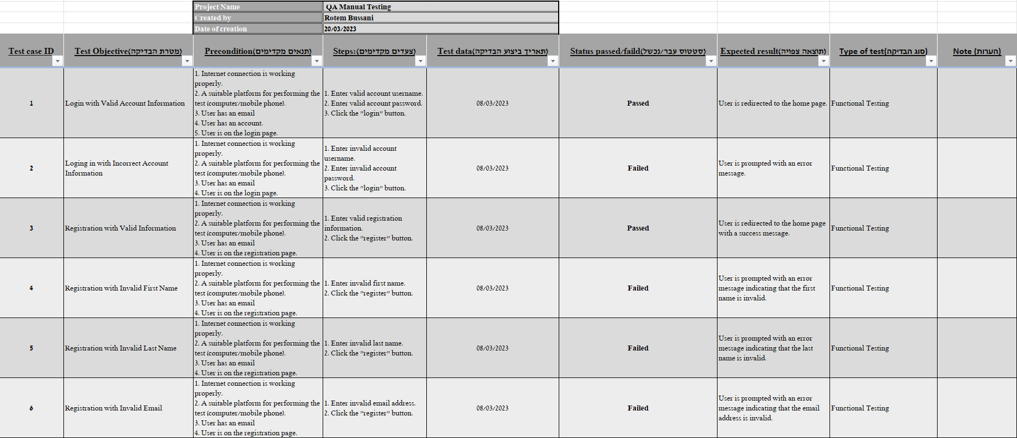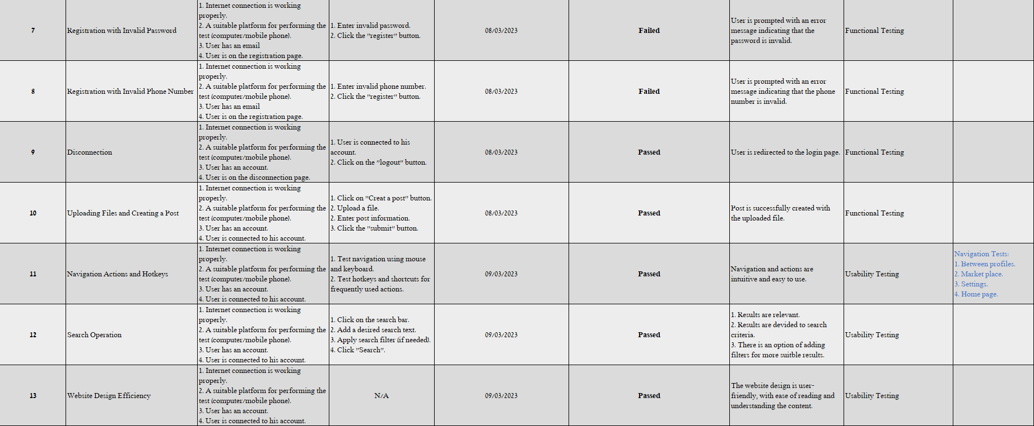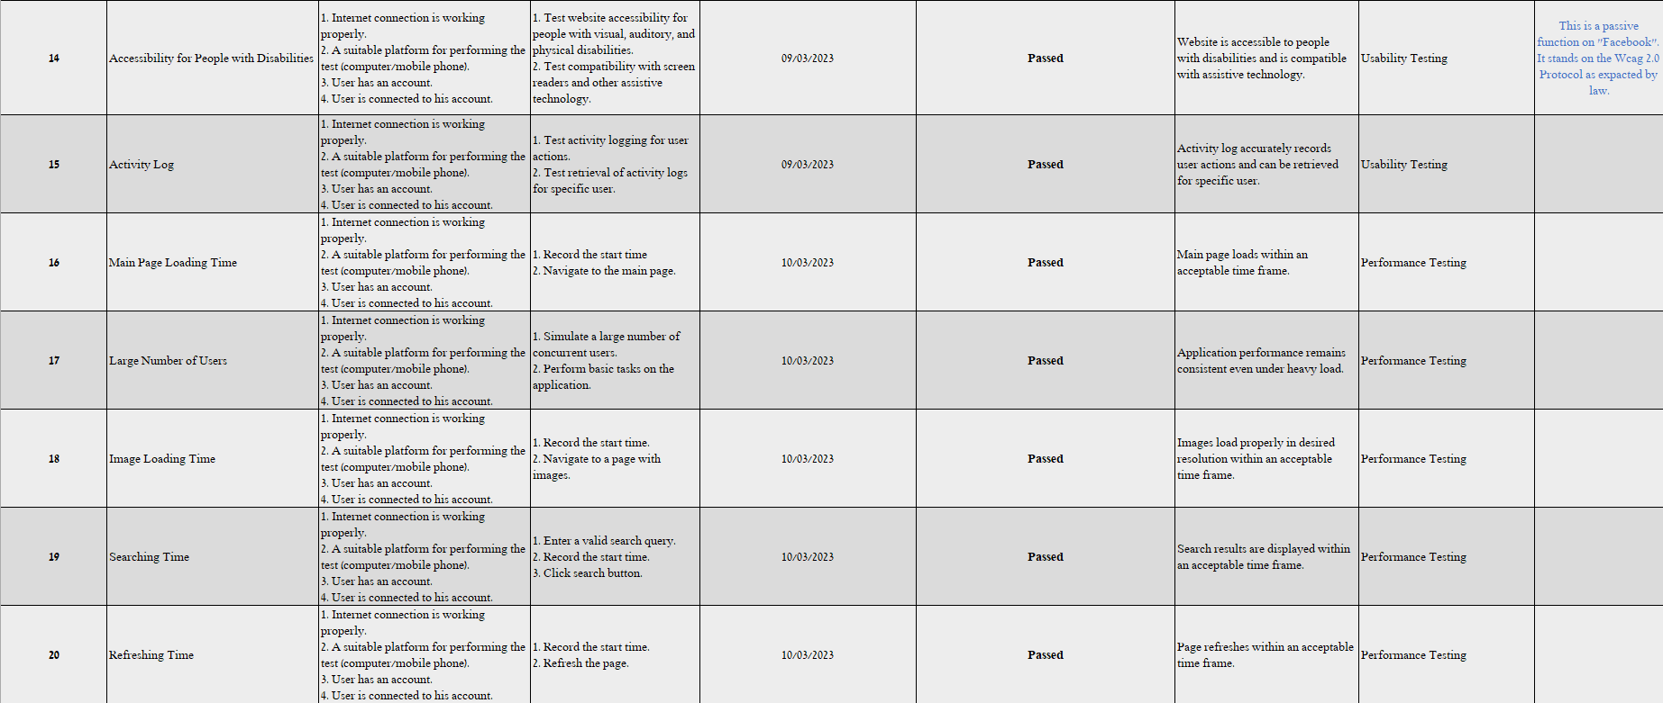

Figure ‎5‑2: Test Cases (21-32)

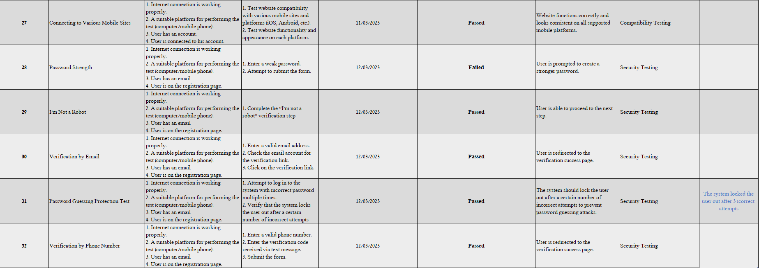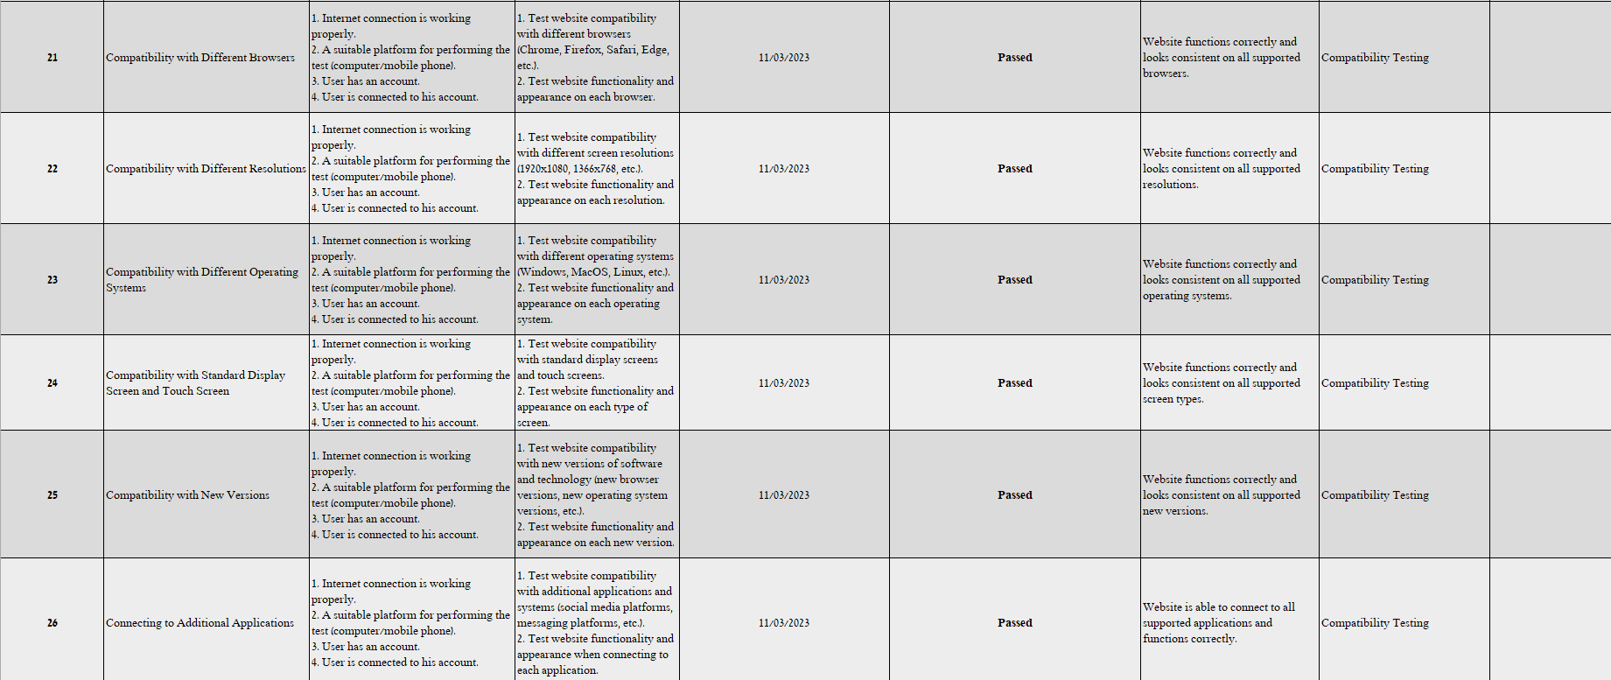

## Bug Reporting and Tracking:

Table ‎5‑1 shows the Bug description, from the cases performed from the figures above (Figure ‎5‑1, Figure ‎5‑2). The table below offers a fixing solution as described by the tester.

Table ‎5‑1: Bug Reporting and Tracking

|  |  |  |  |
| --- | --- | --- | --- |
| Bug ID | Description | Fixing suggestion | Note |
| 1001 | Lack of accessibility button for people with disabilities | Installation of an accessibility button for people with disabilities | Facebook complies with the law, but there is no accessible and convenient solution for a disabled user. |

## Jira:

All Test Cases presented above (Figure ‎5‑1, Figure ‎5‑2) were implemented to “Jira” platform. There is a full description for each Test Case presented on the “Jira” website as shown in Figure ‎5‑3 and Figure ‎5‑4.

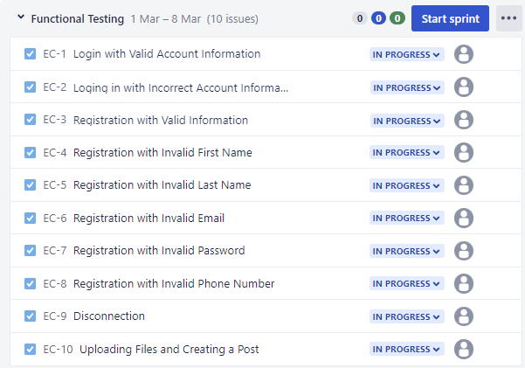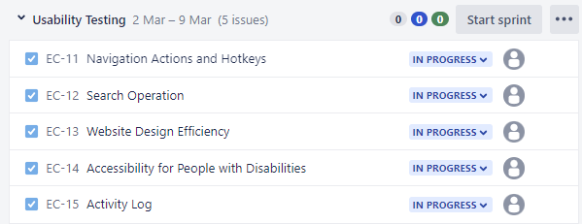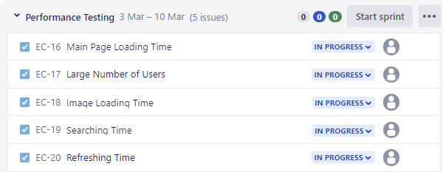

Figure ‎5‑4: Test Cases on Jira (Case 21-32)

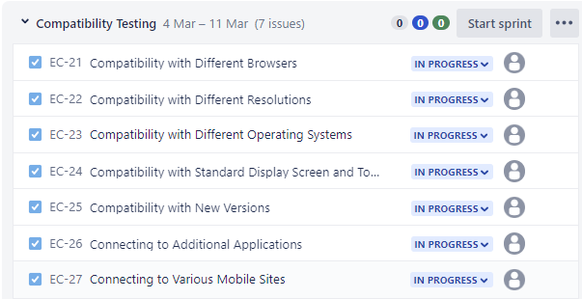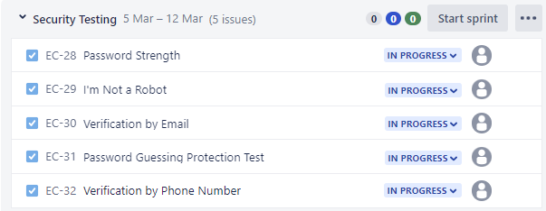

Figure ‎5‑3: Test Cases on Jira (Case 1-20)

Examples for Full description for a test case after implementation on the “Jira” platform are presented the figures below (Figure ‎5‑5, Figure ‎5‑6).

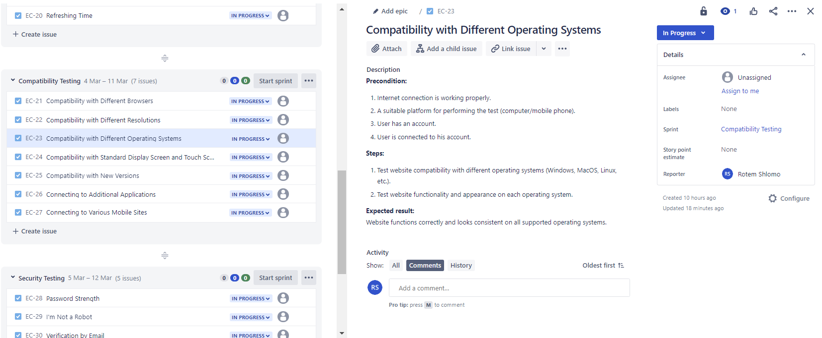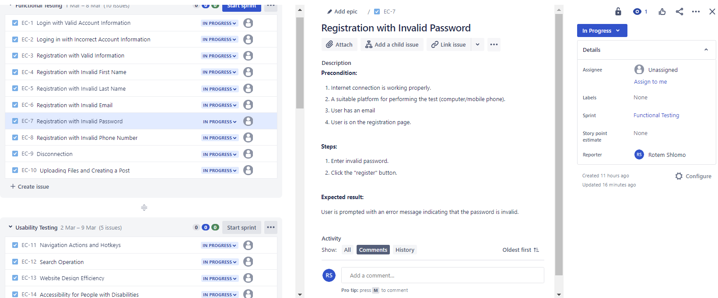

Figure ‎5‑5: Full description on Jira (Case 23)

Figure ‎5‑6: Full description on Jira (Case 7)